Customer Engagement and Product Utilization Analytics for Customer Retention
A Data-Driven Banking Approach

Abstract
This study analyzes customer engagement, product utilization, relationship strength, and churn using a banking dataset containing 10,000 customer records. Overall churn is 20.37% and retention is 79.63%. Customers hold an average of 1.53 products and the average relationship-strength score is 50.6/100. The results are presented through a Streamlit dashboard to support targeted retention decisions.

1. Introduction
Customer retention is an important banking objective because losing customers can reduce long-term relationship value. This project combines customer activity, product ownership, financial characteristics, and churn status to identify useful retention patterns.

2. Objectives
- Measure churn and retention.
- Classify customers by engagement.
- Analyze product utilization and churn.
- Measure relationship strength.
- Identify retention opportunities.
- Present results through an interactive dashboard.

3. Dataset and Key Results
The European_Bank.csv dataset contains demographic, financial, product, activity, salary, and churn fields.
Table 1. Key Project Metrics
Metric | Value
Customers | 10000.00
Churn Rate (%) | 20.37
Retention Rate (%) | 79.63
Average Products | 1.53
Relationship Score | 50.59

4. Methodology
The workflow includes duplicate removal, numeric conversion, missing-value handling, engagement classification, product utilization analysis, relationship-strength scoring, churn comparison, and visualization.
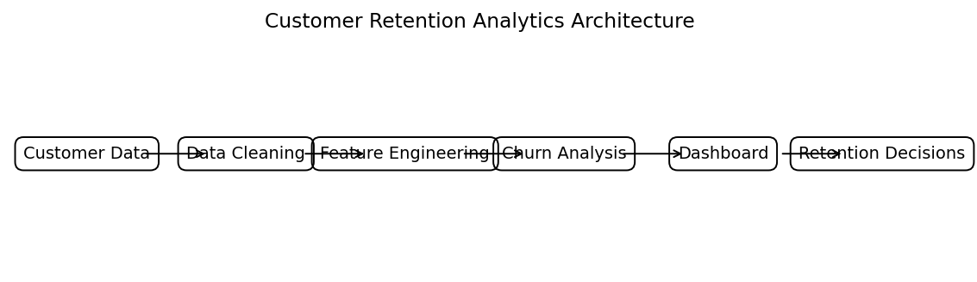
Figure 1. Customer Retention Analytics Architecture.

5. Engagement Analysis
Table 2. Engagement Profile Results
EngagementProfile | Customers | ChurnRate
Active Engaged | 2588 | 9.66
Active Low-Product | 2563 | 18.92
Inactive Disengaged | 2493 | 21.26
Inactive High-Balance | 2356 | 32.77
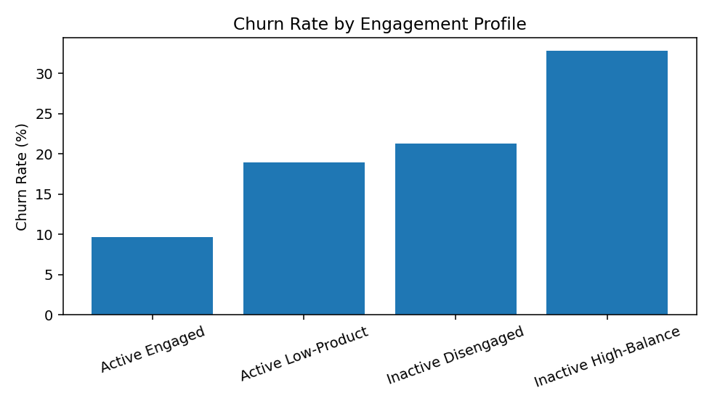
Figure 2. Churn Rate by Engagement Profile.

6. Product Utilization Analysis
Table 3. Product Utilization Results
NumOfProducts | Customers | ChurnRate
1.00 | 5084.00 | 27.71
2.00 | 4590.00 | 7.58
3.00 | 266.00 | 82.71
4.00 | 60.00 | 100.00
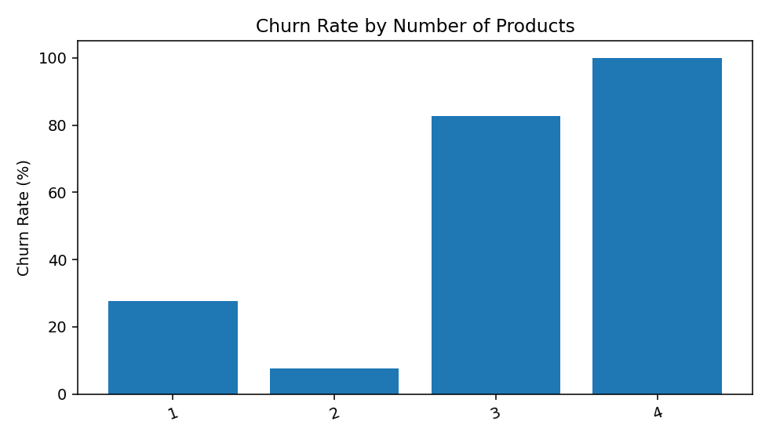
Figure 3. Churn Rate by Number of Products.

7. Relationship Strength Analysis
Table 4. Relationship Strength Results
RelationshipStrength | Customers | ChurnRate
Moderate | 3988 | 23.19
Strong | 3417 | 19.32
Very Strong | 1877 | 10.87
Weak | 718 | 34.54
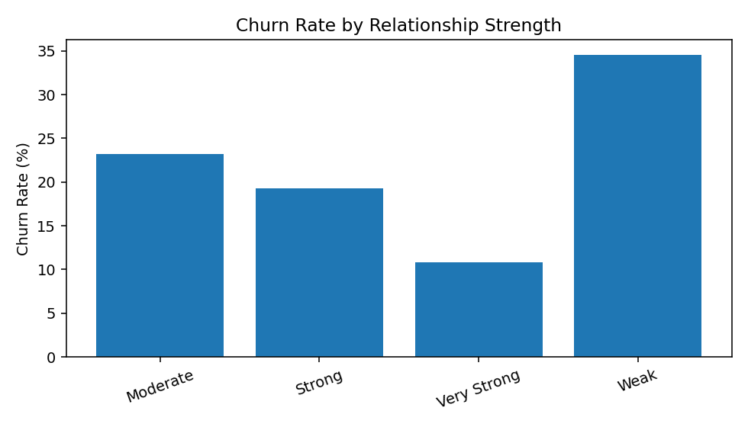
Figure 4. Churn Rate by Relationship Strength.
The relationship-strength index is a project-defined analytical score based on active membership, product count, and credit-card ownership.

8. Geographic Analysis
Table 5. Geographic Results
Geography | Customers | ChurnRate
France | 5014 | 16.15
Germany | 2509 | 32.44
Spain | 2477 | 16.67
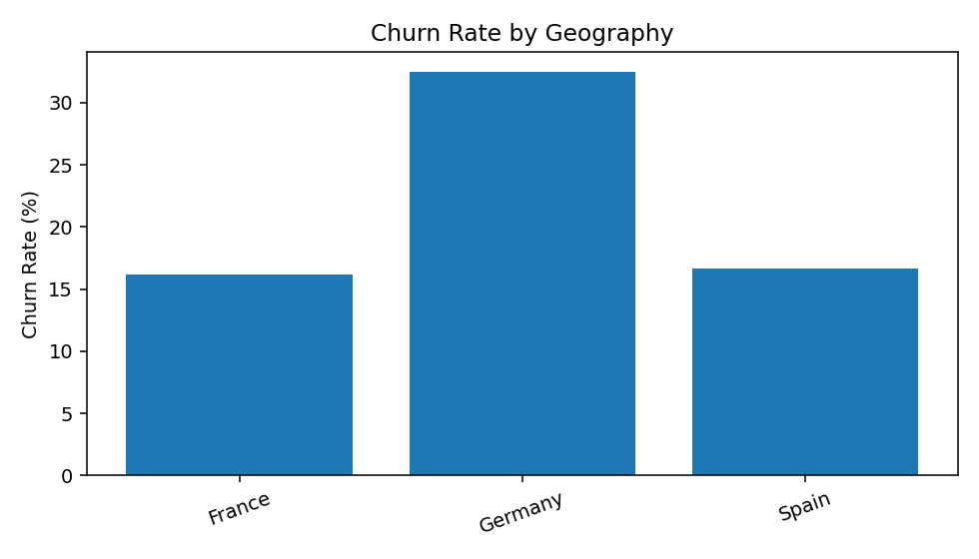
Figure 5. Churn Rate by Geography.

9. Findings and Recommendations
- Overall churn is 20.37%, indicating a meaningful retention opportunity.
- Use engagement segments to prioritize customer outreach.
- Prioritize inactive high-balance customers for proactive contact.
- Use product utilization to identify cross-selling and relationship-building opportunities.
- Use geographic differences to support targeted retention campaigns.

10. Limitations
The analysis is primarily descriptive and does not establish causal relationships. Engagement categories and the relationship-strength index are project-defined rules. Future work can include predictive machine learning, customer lifetime value, and campaign experiments.

11. Conclusion
The project demonstrates a practical approach to banking retention analytics. Combining engagement, product utilization, relationship strength, and geography provides a clear framework for identifying customer-risk patterns and supporting targeted retention strategies across 10,000 customers.

References
- European_Bank.csv, project dataset.
- McKinney, W. (2022). Python for Data Analysis. O'Reilly Media.
- Plotly Technologies Inc. Plotly Python documentation.
- Streamlit Inc. Streamlit documentation.

Dashboard Link
https://customer-engagement-appuct-utilization-analytics-wzcu9mc4ki7fp.streamlit.app/

